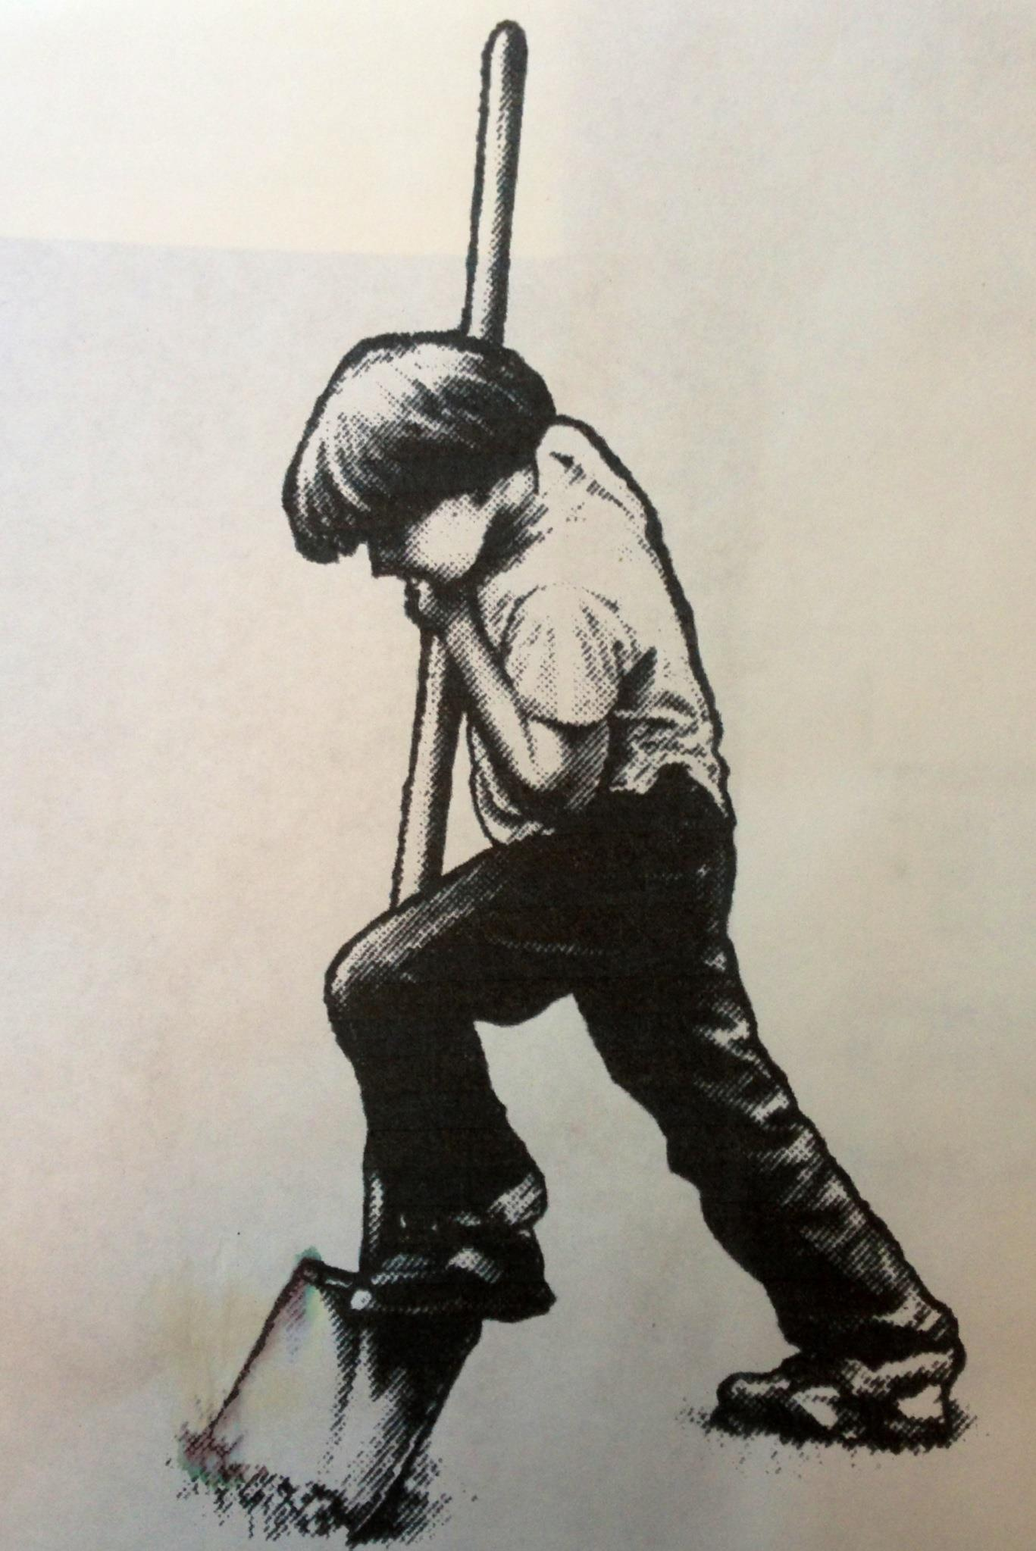

FORESTVILLE YOUTH PARK

P.O. Box 357 • Forestville, CA 95436

**Dates:** June 4 & June 5, 2016 **Hours:** 10:30am to 7:00pm

**Regulations:**

1. The Vendor Coordinator will be available for site assignments and booth set up between 4pm-5pm Friday June 3 or Saturday June 4 at 9am. Vendors must first check in for their site assignments. Please do not set up your booth without site approval or you may have to move.
2. Booths must be set up and operational between the hours of 10:00 am and 5:00 pm during the BBQ, and must remain open during these hours. Your booth may remain open later if you choose to do so.
3. Electricity is NOT available.
4. Vendors must provide their own booth and/or tables, chairs, covering or tenting for booths.
5. Vendors must at all time keep their space properly cleaned and arranged. Vendors are responsible for their own clean up.
6. Vendors are responsible for securing their booths and merchandise. Park security will not be responsible for vendor’s booths or its contents.
7. Sound devices of any type are subject to the approval of the Youth Park Directors.
8. The Forestville Youth Park board of directors reserves the right to prohibit an exhibit/concession or any part thereof which in the sole judgment of the Directors detracts from the character of the event or which may be objectionable or offensive to neighboring stands or the public. This limitation extends without limitation to persons, things, conduct, signage, products or printed matter.
9. **No dogs** are allowed on the Youth Park property at any time, with the exception of service dogs.

The undersigned has registered as a vendor for the 2016 Forestville Youth Park BBQ. The undersigned assumes all risk and shall be responsible for all injury or damage of any kind to person’s property (regardless of who may be the owner of the property) resulting from the participation of the undersigned in the 2016 Forestville Youth Park BBQ.

In addition to the undersigned’s liability for personal injury or property damage suffered through the undersigned’s negligence, which liability is not impaired or otherwise affected hereunder, the undersigned shall indemnify and hold harmless the Forestville Youth Park, it’s agents, board members and employees from and against all loss, claims for damages or expense (including costs and attorney’s fees), arising in any manner out of the presence, activity, food, crafts or equipment of the undersigned and for damages thereof.

Signature: ___________________________________ Date: _________________

Print Name: ___________________________________