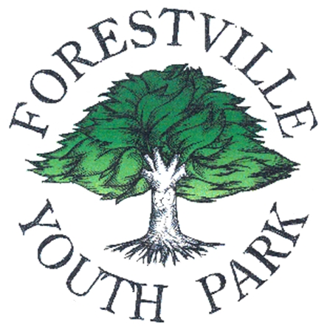

FORESTVILLE PARK DEVELOPMENT, INC.

P.O. Box 357 • Forestville, CA 95436

Forestville Youth Park’s

Annual BBQ, Parade and Carnival

June 9th & 10th, 2012

VENDOR APPLICATION

Name: ______________________________ Phone Number: ______________________
Address: ________________________________________________________________
City: ____________________________ State: _____________ Zip: ________________
E-Mail: ______________________________Fax Number: ________________________
Resale Number: __________________________________________________________
Description of items to be sold:
(Please provide photos of your booth and of items to be sold if this is your first time participating)
________________________________________________________________________
________________________________________________________________________
________________________________________________________________________
________________________________________________________________________
Fees: $75.00 for one day or $100.00 for both and must be paid in advance to reserve a space. Email confirmation will be sent upon receipt.
Set-Up: Booth must be set up between the hours of 7:00am to 10:00am Saturday morning.
Prior arrangements can be made for Friday setup.
Vendors are responsible for their own booth, and clean up! *Please check in with the Vendor Coordinator prior to setting up.

Utilities: Electrical outlets are NOT available.
Hours: Booths must remain open until 5pm. You may stay open later if you wish.
Site: Site sizes are approximately 10’ x 10’, larger sites can be accommodated.

Please make checks payable to: Forestville Park Development, Inc.
And mail with signed regulation form to:
Shawn Roades
Forestville Park Development, Inc.

P.O. Box 943
Forestville, CA 95436

